HEALTH RISK ASSESSMENT SYSTEM
Submitted for

ARTIFICIAL INTELLIGENCE AND Machine Learning CSET211

Submitted by:
(E23CSEU0190) Anuhska Avanti
(E23CSEU0208) Rohan Singh

Submitted to
DR Akhilesh

Jan-May 2024
SCHOOL OF COMPUTER SCIENCE AND ENGINEERING


INDEX

Sr.No | Content | Page No
1. | Abstract
2. | Introduction
3. | Related Work
4. | Methodology
5. | Experimental Results
6. | Conclusions
7. | Future Scope
8. | GitHub Link

- Abstract
Over the past few years, the integration of Artificial Intelligence (AI) with healthcare systems has created major breakthroughs in the detection of diseases and preventive diagnostic capability. This project describes the development of a Health Risk Assessment System (HRAS) that integrates text-based symptom analysis, lifestyle factor assessment, and image-based medical diagnosis to provide an overall health prediction tool. The system uses natural language processing and machine learning methods for symptom analysis, along with deep learning-based chest X-ray analysis to identify respiratory illnesses like tuberculosis. It provides personalized health reports with predicted illnesses, confidence levels, medical descriptions, lifestyle-based precautions, and personalized recommendations. Developed as a full-stack web application using Flask, it provides users with an interactive and intuitive platform for self-health evaluation and early disease detection.

- Introduction
Healthcare systems often struggle with delayed diagnosis due to limitations in accessibility, cost, and lack of early screening tools. With the rise of AI, there's a growing opportunity to develop assistive tools that empower users to assess their health independently and provide timely insights that can prompt early intervention.

The Health Risk Assessment System (HRAS) is designed to address this gap. It functions as an AI-powered diagnostic assistant that accepts natural language symptom descriptions, personal and lifestyle health data, and medical images (e.g., X-rays) to predict potential health risks. It not only provides predictions but also educates users with relevant disease information, recommended precautions, and lifestyle-specific advice. A particularly impactful addition is the system’s ability to detect tuberculosis and related pulmonary conditions through chest X-ray analysis, further enhancing its utility as a comprehensive health screening solution.

- Related Work
Numerous studies have explored the use of AI in healthcare diagnostics. Symptom checkers like WebMD or Ada Health provide rule-based or lightweight machine learning systems for disease prediction. However, these systems often lack customization and integration of real-world lifestyle parameters.
On the imaging front, deep learning models such as CheXNet have shown excellent performance in detecting pathologies from chest X-rays. Several platforms have integrated Convolutional Neural Networks (CNNs) to detect tuberculosis, pneumonia, and COVID-19 using large public datasets like NIH ChestX-ray14 or Montgomery Dataset.
Unlike existing tools that focus on either symptoms or imaging, our system bridges this divide by integrating both approaches into a single, user-friendly web platform with real-time prediction capabilities.

- Methodology
The system employs a hybrid AI approach combining machine learning and deep learning for health risk assessment.

4.1 Symptom & Lifestyle-Based Prediction
- Text Preprocessing: User symptoms are processed using TF-IDF vectorization to convert text into numerical form.
- Feature Integration: Lifestyle-related inputs (e.g., smoker, diabetes, hypertension) are combined with symptom vectors.
- Classification: A Random Forest classifier predicts the most probable diseases, returning the top 3 predictions with confidence scores, medical descriptions, general precautions, and custom recommendations based on user profile.

4.2 Medical Image Analysis (CNN)
- For high-risk diseases (e.g., Tuberculosis, Pneumonia), users can upload chest X-ray images.
- A Convolutional Neural Network (CNN) model analyzes the images to assist or verify disease prediction.
- The CNN uses two convolutional and pooling layers followed by fully connected layers for binary classification (e.g., disease vs. no disease).

4.3 Final Diagnosis Summary
The system merges insights from:
- Symptom-based prediction
- Lifestyle risk scoring
- Optional image-based confirmation (for high-risk conditions) to generate a comprehensive diagnosis summary.

4b.) Dataset Development
4.1 Symptom & Lifestyle Dataset
- Collected from open-source medical repositories and cleaned to include:
  - Disease name
  - Associated symptoms
  - Lifestyle factors (binary)
  - Disease stage (numeric)
- Used to train the Random Forest classifier with TF-IDF features and encoded lifestyle attributes.
4.2 Medical Imaging Dataset
- Chest X-ray images sourced from publicly available datasets (e.g., NIH Chest X-ray or COVIDx) for training the CNN model.
- Images are resized to 150×150 pixels, normalized, and labeled for binary classification tasks.
4c) Web Application
The frontend is built using HTML, CSS, and JavaScript, served via a Flask backend.
- Form Page: Collects user inputs like symptoms, age, gender, lifestyle habits, and optionally a scan image.
- Results Page: Displays predictions with confidence, descriptions, precautions, and custom health tips.
- Visualization: Uses chart.js to graphically represent prediction probabilities.

- Experimental Result
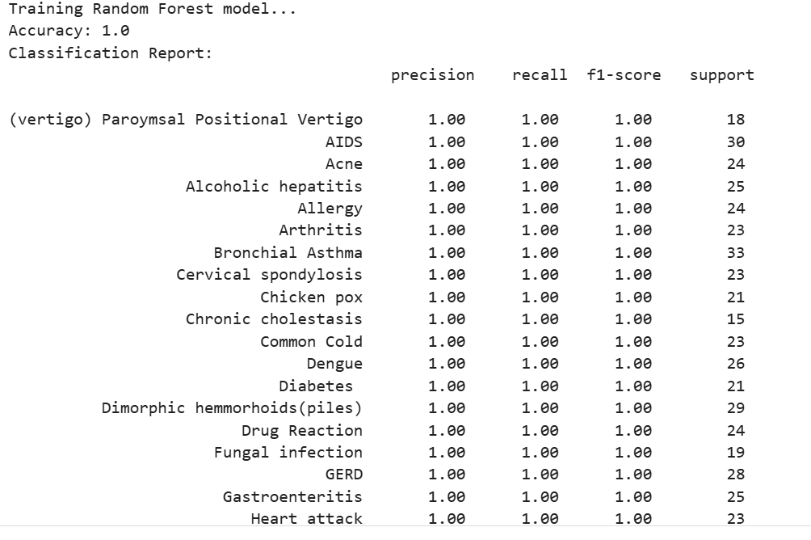
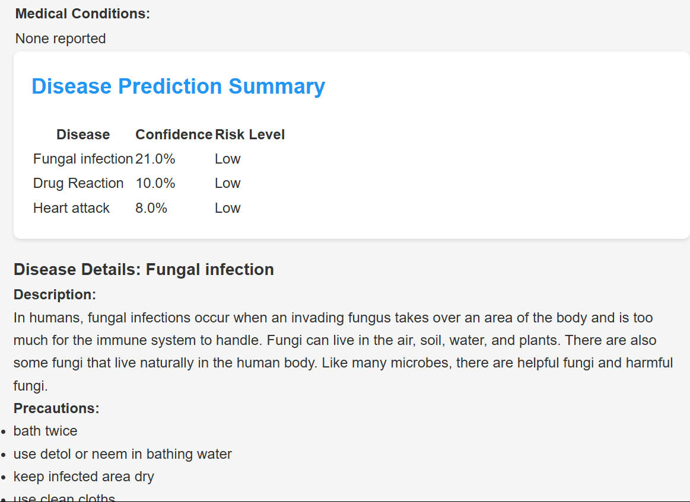
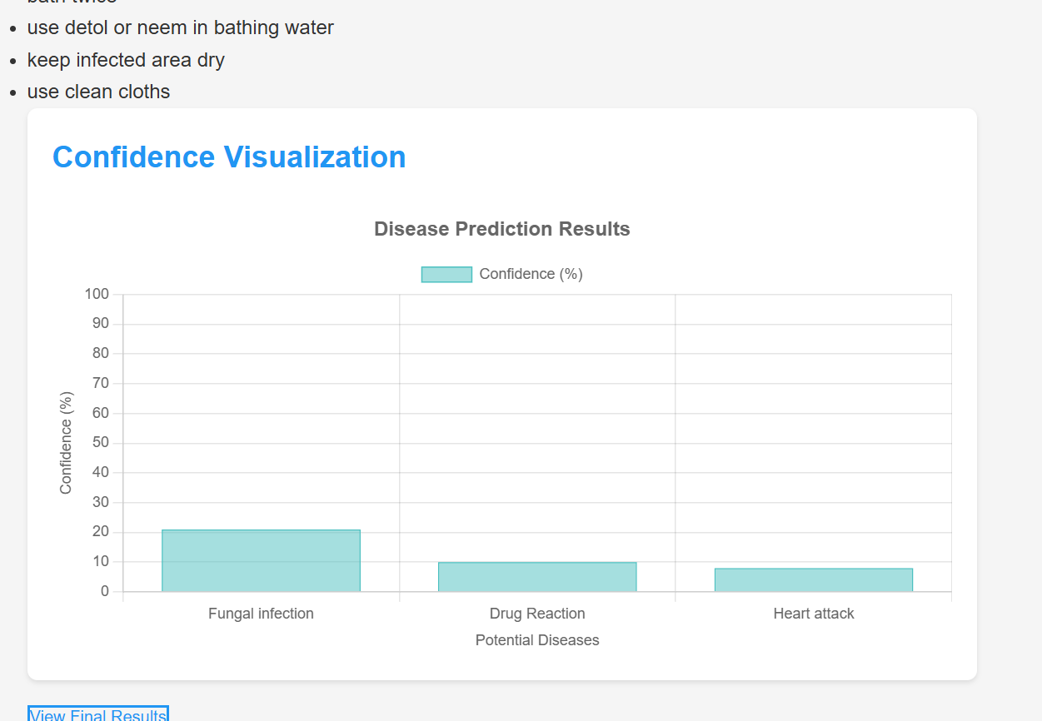
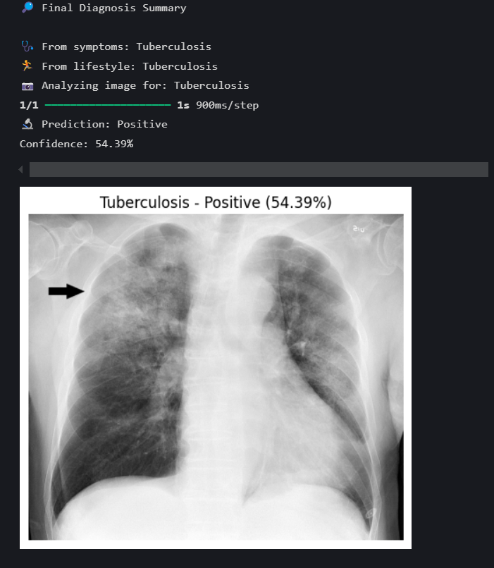

- Conclusions
This project demonstrates a hybrid AI-based Health Risk Assessment System that combines symptom analysis, lifestyle evaluation, and medical image interpretation for more accurate disease prediction. By integrating multiple input modalities, the system aims to support early detection and informed decision-making.
6.1 Limitations & Challenges
- Data Limitations: The symptom-lifestyle dataset may not capture rare or emerging diseases. Image datasets may lack diversity in demographics and image quality.
- Binary Image Classification: The CNN currently supports only binary outputs (e.g., TB vs. No TB), limiting its use for multi-class diagnoses.
- Generalization: The model might not perform well on unseen symptom patterns or complex comorbidities due to limited training data.
- User Input Dependency: Accuracy depends on the user entering correct and detailed symptoms.
- Image Quality Variance: Image analysis can be affected by upload quality, lighting, or resolution inconsistencies.

- Future Scope
- Multi-class Image Classification: Expand CNN models to detect multiple diseases like Pneumonia, Lung Cancer, and COVID-19.
- NLP-based Symptom Parsing: Enhance symptom understanding using advanced language models for better user input interpretation.
- Real-time Feedback Loop: Integrate user feedback to continuously improve model predictions.
- Wearable & Sensor Integration: Include data from fitness trackers or medical sensors for real-time health monitoring.
- Mobile Application Deployment: Build a cross-platform mobile app for broader accessibility and convenience.
- Doctor Dashboard: Develop an admin panel for doctors to review cases, track trends, and update recommendations.

